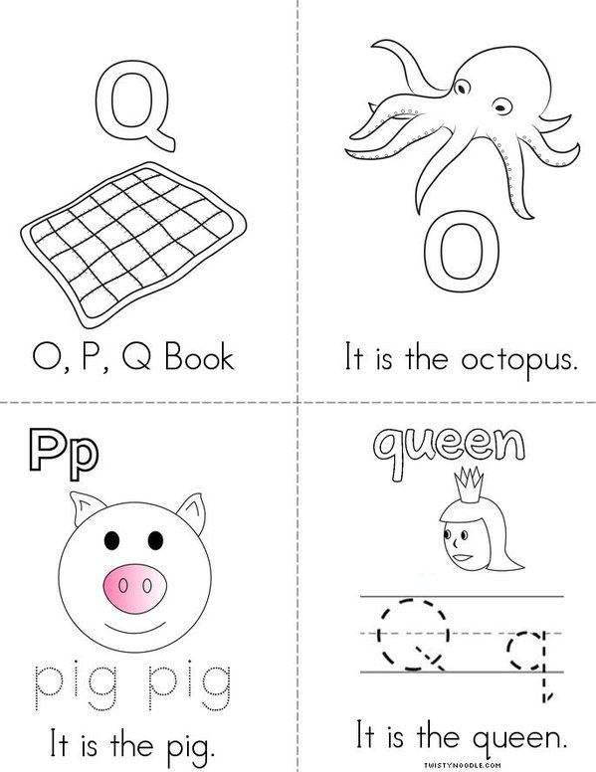

Name

Oo, Pp and Qq

Review Book

Name

___________________________________________

__________