February Project My Family Tree

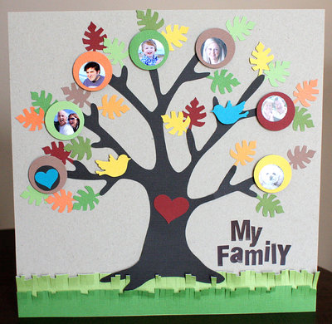
My Family Tree (example project)

sas
Hello Parents/Guardians,
February is Black History Month. Our Preschool children will each create their ‘Family Tree.’ Children will share the history of their own family by identifying members including themselves, sisters and brothers, parents and grandparents on the tree. Help your child complete their project which will be displayed in our classroom and in the hallways. ALL projects are expected to be completed and returned by
Name

sas
Monday, February 11, 2019.

Directions: Purchase a pack of construction paper from the Dollar tree and a glue stick. Use a half sheet of poster board to display your project.
Study the picture of the ‘Family Tree’ provided. Cut out similar shapes for your tree. Use photos or have your child draw the face of each family member.
Your child will present their ‘Family Tree’ to the class. Practice at home with them identifying all the people that are on it. Encourage them to speak loudly and clearly during their presentation.

Thank you,
Preschool Staff

